**Test Preparation Skills**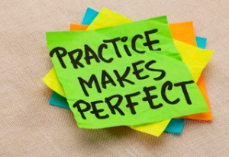

Bright Minds works with each student to help them prepare for exams as efficiently as possible. During lessons, Bright Minds teachers give assessments to target areas of need, teach a lesson guided by the test results, and provide a post-test which demonstrates mastery. These tests are kept in each student’s portfolio as a record of their progress. In addition, Instructors help students understand how to prepare notes and flash cards, and create a regular routine to follow at home.

Students at Bright Minds are coached in recognizing and comprehending patterns in test questions, prioritizing, managing time, and withstanding distractions so that they can maximize their time when taking exams. Strategies for answering different types of test questions such as multiple choice, short-answer and essay responses are provided to each student. For example, students are taught to think critically about all available choices, try to determine the answers that are most likely to be correct, and to complete pre-writing to help organize their thoughts effectively before completing a timed essay.

Bright Minds instructors teach strategic approaches to test-taking in the interest of helping each student achieve the best possible outcome.

Student’s cooperation is essential key element in the possible outcome.

**Test-taking Strategies**

Familiarity and skillfulness with classroom and standardized testing is essential for a student’s academic success. Bright Minds offers support for students who experience performance anxiety by practicing test-taking in a calm and positive environment. The goal is to help students feel comfortable and grounded while their skills are being evaluated. Bright Minds is dedicated to helping students realize that the testing and assessment process is an opportunity to demonstrate their mastery of knowledge.

When students are tested frequently in a gentle and supportive environment, they build positive associations with exams and their anxiety is greatly decreased. Bright Minds helps to build students’ academic confidence so that they feel secure in their ability to perform.

Additionally, students entering private schools or high school students who are preparing to take college entrance exams (ISEE, PSAT, SAT, ACT, MAT, AP Exams) can come to Bright Minds to learn how to efficiently prepare. Instructors at Bright Minds guide students through a review of material that will be covered and provide regular opportunities for timed practice so that when test day comes, students feel confident and can focus on doing their best.